**COMSATS University Islamabad, Lahore Campus**

## 

## Microprocessor and Assembly

# Final Term – Lab Exam

* **Submitted By:** M. Maiz Nadeem
* **Registration Number:** SP21-BCS-052
* **Session:** BCS – B (FALL 2022)
* **Date:** 12th Jan, 2022
* **Submitted To:** Sir Amaid Zia

# Question no 1

## Code:

|  |
| --- |
| ORG 100h |
|  |
| .DATA |
|  |
| RESULT  *DW*  0 |
| TERM1   *DW*  0 |
| TERM2   *DW*  0 |
| TERM3   *DW*  0 |
| N       *DW*  5 |
|  |
| .CODE |
|  |
| MAIN PROC |
|  |
| MOV AX, N |
| DEC AX |
| PUSH AX |
| CALL SEQUENCE |
|  |
| RET |
| MAIN ENDP |
|  |
|  |
| SEQUENCE PROC |
|  |
| MOV BP, SP |
| MOV BX, [BP+2] |
| MOV N, BX |
|  |
| CMP N, 0 |
| JNE CMP2 |
| MOV RESULT, 2 |
| JMP EXIT |
|  |
| CMP2:       CMP N, 1 |
| JNE CMP3 |
| MOV RESULT, 4 |
| JMP EXIT |
|  |
| CMP3:       CMP N, 2 |
| JNE NEXT |
| MOV RESULT, 7 |
| JMP EXIT |
|  |
|  |
| NEXT:       DEC N |
| PUSH N |
| CALL SEQUENCE |
|  |
| MOV BP, SP |
| MOV BX, [BP+2] |
| MOV N, BX |
|  |
| PUSH RESULT |
|  |
| SUB N, 2 |
| PUSH N |
| CALL SEQUENCE |
|  |
| POP TERM3 |
| MOV BP, SP |
| MOV BX, [BP+2] |
| MOV N, BX |
|  |
| PUSH RESULT |
|  |
| SUB N, 3 |
| PUSH N |
| CALL SEQUENCE |
|  |
|  |
| POP TERM2 |
| MOV BP, SP |
| MOV BX, [BP+2] |
| MOV N, BX |
|  |
| MOV BX, RESULT |
| MOV TERM1, BX |
| MOV RESULT, 0 |
|  |
| MOV AX, TERM1 |
| MOV BX, 4 |
| MUL BX |
| MOV RESULT, AX |
| MOV AX, TERM3 |
| MUL N |
| SUB AX, TERM2 |
| ADD RESULT, AX |
| MOV AX, TERM3 |
| MOV RESULT, AX |
|  |
|  |
| EXIT: |
| RET 2 |
| SEQUENCE ENDP |

## Output:

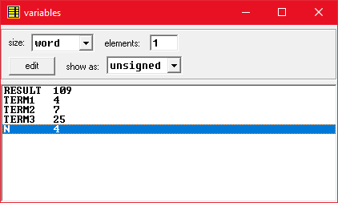

# Question no 2

## Code:

|  |
| --- |
| ORG 100h |
|  |
| .DATA |
|  |
| ARR     *DW*  0500h |
| COUNT   *DW*  0 |
|  |
| RIGHT   *DW*  0 |
| DOWN    *DW*  0 |
| LEFT    *DW*  0 |
| UP      *DW*  0 |
|  |
| RFLAG   *DW*  0 |
| DFLAG   *DW*  0 |
| LFLAG   *DW*  0 |
| UFLAG   *DW*  0 |
|  |
|  |
| .CODE |
|  |
| MOV BX, ARR |
|  |
|  |
| INPUTSTRING:    MOV AH, 1 |
| INT 21H |
| CMP AL, 0x0D |
| JE  NEXT |
| MOV [BX], AL |
| INC BX |
| INC COUNT |
| JMP INPUTSTRING |
|  |
|  |
|  |
| NEXT:    MOV DX, COUNT |
| DEC DX |
| MOV AX, 160 |
| MUL DX |
| MOV DX, 22*160+2*2 |
| SUB DX, AX |
| MOV RIGHT, DX           ; CALCULATING STRING'S RIGHT MOVING INDEX |
|  |
|  |
| MOV DX, RIGHT |
| ADD DX, 152 |
| SUB DX, COUNT |
| SUB DX, COUNT |
| MOV UP, DX              ; CALCULATING STRING'S   UP  MOVING INDEX |
|  |
|  |
| MOV DX, 2*160+77*2 |
| SUB DX, COUNT |
| SUB DX, COUNT |
| ADD DX, 2 |
| MOV LEFT, DX            ; CALCULATING STRING'S  LEFT MOVING INDEX |
|  |
|  |
| MOV DX, 2*160+2*2 |
| MOV DOWN, DX            ; CALCULATING STRING'S  DOWN MOVING INDEX |
|  |
|  |
|  |
| ; DISPLAY MODE |
|  |
| MOV SI, RIGHT           ; STARTING INDEX |
| SUB SI, 2 |
|  |
| MOV AH, 0 |
| MOV AL, 3 |
| INT 10H |
|  |
| MOV AX, 0xB800 |
| MOV ES, AX |
| MOV AH, 0x07 |
|  |
|  |
| RIGHTMOVE:    MOV RFLAG, 1 |
| MOV DFLAG, 0 |
| MOV LFLAG, 0 |
| MOV UFLAG, 0            ; PREVENTS MOVING STRING IN OTHER DIRECTIONS |
|  |
| ADD SI, 2 |
| MOV BX, ARR |
| MOV CX, COUNT |
| JMP STRINGPRINT |
|  |
| UPMOVE:    MOV RFLAG, 0 |
| MOV DFLAG, 0 |
| MOV LFLAG, 0 |
| MOV UFLAG, 1 |
|  |
| SUB SI, 160 |
| MOV BX, ARR |
| MOV CX, COUNT |
| JMP STRINGPRINT |
|  |
| LEFTMOVE:    MOV RFLAG, 0 |
| MOV DFLAG, 0 |
| MOV LFLAG, 1 |
| MOV UFLAG, 0 |
|  |
| SUB SI, 2 |
| MOV BX, ARR |
| MOV CX, COUNT |
| JMP STRINGPRINT |
|  |
| DOWNMOVE:    MOV RFLAG, 0 |
| MOV DFLAG, 1 |
| MOV LFLAG, 0 |
| MOV UFLAG, 0 |
|  |
| ADD SI, 160 |
| MOV BX, ARR |
| MOV CX, COUNT |
| JMP STRINGPRINT |
|  |
|  |
| STRINGPRINT:    CMP CX, 0 |
| JE  PRINTNEXT |
| MOV AL, [BX] |
| MOV ES:SI, AX |
| ADD SI, 162 |
| INC BX |
| DEC CX |
| JMP STRINGPRINT          ; PRINTS STRING DIAGONALLY |
|  |
|  |
| PRINTNEXT:    MOV CX, COUNT |
|  |
| ERASE:    MOV AH, 0X07 |
| MOV AL, ' ' |
| MOV ES:SI, AX |
| SUB SI, 162 |
| LOOP ERASE               ; ERASES STRING DIAGONALLY |
|  |
| MOV ES:SI, AX |
|  |
| CMP SI, UP |
| JE  UPMOVE               ; SHIFTS STRING UP |
| CMP SI, LEFT |
| JE  LEFTMOVE             ; SHIFTS STRING LEFT |
| CMP SI, DOWN |
| JE  DOWNMOVE             ; SHIFTS STRING DOWN |
| CMP SI, RIGHT |
| JE  RIGHTMOVE            ; SHIFTS STRING RIGHT |
|  |
|  |
| CMP UFLAG, 1 |
| JE  UPMOVE |
| CMP LFLAG, 1 |
| JE  LEFTMOVE |
| CMP DFLAG, 1 |
| JE  DOWNMOVE |
| CMP RFLAG, 1 |
| JE  RIGHTMOVE            ; MAKES STRING KEEP MOVING IN SAME DIRECTION |

## Output:

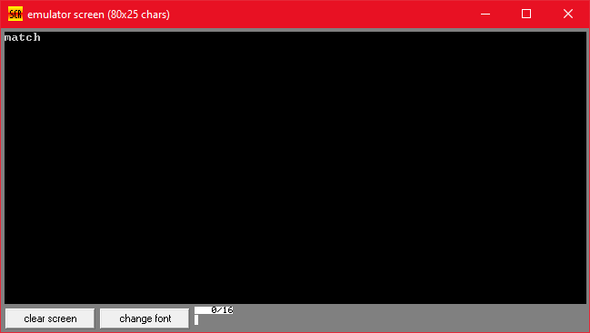

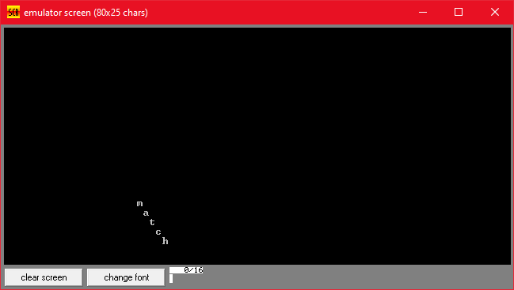

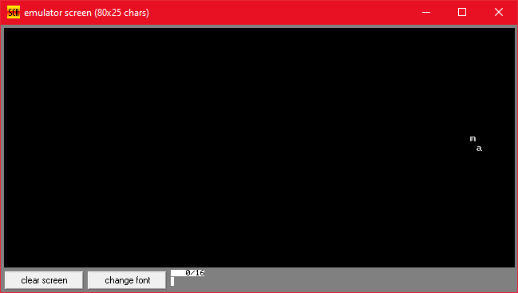

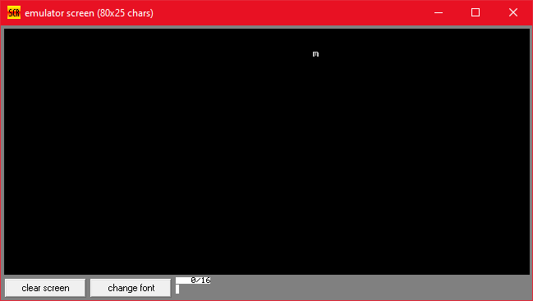

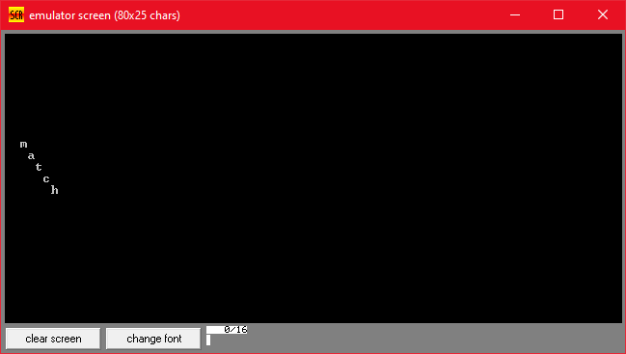

# Question no 3

## Code:

|  |
| --- |
| ORG 100h |
|  |
| .DATA |
|  |
| ARR     *DW*  'match' |
| COUNT   *DW*  5 |
|  |
| RIGHT   *DW*  0 |
| DOWN    *DW*  0 |
| LEFT    *DW*  0 |
| UP      *DW*  0 |
|  |
| RFLAG   *DW*  0 |
| DFLAG   *DW*  0 |
| LFLAG   *DW*  0 |
| UFLAG   *DW*  0 |
|  |
| FLAG    *DW*  0 |
| CFLAG   *DW*  0 |
| TFLAG   *DW*  0 |
| TCOUNT  *DW*  0 |
|  |
|  |
| .CODE |
|  |
| CLI |
| MOV AX, 0 |
| MOV ES, AX |
| MOV SI, 9*4 |
| MOV ES:SI, OFFSET KBISR |
| ADD SI, 2 |
| MOV ES:SI, CS |
| MOV SI, 8*4 |
| MOV ES:SI, OFFSET TISR |
| ADD SI, 2 |
| MOV ES:SI, CS |
| STI |
|  |
| LEA BX, ARR |
|  |
|  |
|  |
| NEXT:    MOV DX, COUNT |
| DEC DX |
| MOV AX, 160 |
| MUL DX |
| MOV DX, 22*160+2*2 |
| SUB DX, AX |
| MOV RIGHT, DX           ; CALCULATING STRING'S RIGHT MOVING INDEX |
|  |
|  |
| MOV DX, RIGHT |
| ADD DX, 152 |
| SUB DX, COUNT |
| SUB DX, COUNT |
| MOV UP, DX              ; CALCULATING STRING'S   UP  MOVING INDEX |
|  |
|  |
| MOV DX, 2*160+77*2 |
| SUB DX, COUNT |
| SUB DX, COUNT |
| ADD DX, 2 |
| MOV LEFT, DX            ; CALCULATING STRING'S  LEFT MOVING INDEX |
|  |
|  |
| MOV DX, 2*160+2*2 |
| MOV DOWN, DX            ; CALCULATING STRING'S  DOWN MOVING INDEX |
|  |
|  |
|  |
| ; DISPLAY MODE |
|  |
| MOV SI, RIGHT           ; STARTING INDEX |
| SUB SI, 2 |
|  |
| MOV AH, 0 |
| MOV AL, 3 |
| INT 10H |
|  |
| MOV AX, 0xB800 |
| MOV ES, AX |
| MOV AH, 0x07 |
|  |
| INTERRUPT:    ;CMP TFLAG, 1 |
| ;JNE NEXTCOMP |
| ;MOV TFLAG, 0 |
| ;JMP RIGHTMOVE |
|  |
| NEXTCOMP:    CMP FLAG, 1 |
| JNE AGAIN |
|  |
|  |
| RIGHTMOVE:    MOV RFLAG, 1 |
| MOV DFLAG, 0 |
| MOV LFLAG, 0 |
| MOV UFLAG, 0            ; PREVENTS MOVING STRING IN OTHER DIRECTIONS |
|  |
| ADD SI, 2 |
| LEA BX, ARR |
| MOV CX, COUNT |
| JMP STRINGPRINT |
|  |
| UPMOVE:    MOV RFLAG, 0 |
| MOV DFLAG, 0 |
| MOV LFLAG, 0 |
| MOV UFLAG, 1 |
|  |
| SUB SI, 160 |
| LEA BX, ARR |
| MOV CX, COUNT |
| JMP STRINGPRINT |
|  |
| LEFTMOVE:    MOV RFLAG, 0 |
| MOV DFLAG, 0 |
| MOV LFLAG, 1 |
| MOV UFLAG, 0 |
|  |
| SUB SI, 2 |
| LEA BX, ARR |
| MOV CX, COUNT |
| JMP STRINGPRINT |
|  |
| DOWNMOVE:    MOV RFLAG, 0 |
| MOV DFLAG, 1 |
| MOV LFLAG, 0 |
| MOV UFLAG, 0 |
|  |
| ADD SI, 160 |
| LEA BX, ARR |
| MOV CX, COUNT |
| JMP STRINGPRINT |
|  |
|  |
| STRINGPRINT:    CMP CX, 0 |
| JE  PRINTNEXT |
| MOV AL, [BX] |
| MOV ES:SI, AX |
| ADD SI, 162 |
| INC BX |
| DEC CX |
| JMP STRINGPRINT          ; PRINTS STRING DIAGONALLY |
|  |
|  |
| PRINTNEXT:    MOV CX, COUNT |
|  |
| ERASE:    MOV AH, 0X07 |
| MOV AL, ' ' |
| MOV ES:SI, AX |
| SUB SI, 162 |
| LOOP ERASE               ; ERASES STRING DIAGONALLY |
|  |
| MOV ES:SI, AX |
|  |
| CMP SI, UP |
| JE  UPMOVE               ; SHIFTS STRING UP |
| CMP SI, LEFT |
| JE  LEFTMOVE             ; SHIFTS STRING LEFT |
| CMP SI, DOWN |
| JE  DOWNMOVE             ; SHIFTS STRING DOWN |
| CMP SI, RIGHT |
| JE  RIGHTMOVE            ; SHIFTS STRING RIGHT |
|  |
|  |
| CMP UFLAG, 1 |
| JE  UPMOVE |
| CMP LFLAG, 1 |
| JE  LEFTMOVE |
| CMP DFLAG, 1 |
| JE  DOWNMOVE |
| CMP RFLAG, 1 |
| JE  RIGHTMOVE            ; MAKES STRING KEEP MOVING IN SAME DIRECTION |
|  |
|  |
| AGAIN:    JMP INTERRUPT |
|  |
|  |
| KBISR:    PUSH AX |
| IN  AL, 0x60 |
| CMP AL, 0x2E |
| JNE CHECK_RELEASE |
| MOV CFLAG,1 |
| JMP KEXIT |
|  |
| CHECK_RELEASE:    CMP AL, 0xAA |
| JNE CHECK_A |
| MOV CFLAG, 0 |
| JMP KEXIT |
|  |
| CHECK_A:    CMP AL, 0xAE |
| JNE KEXIT |
| CMP CFLAG, 1 |
| JNE KEXIT |
| MOV FLAG, 1 |
| JMP COMPLETE |
|  |
| KEXIT:    MOV FLAG, 0 |
| COMPLETE:    MOV AL, 0x020 |
| OUT 0x20, AL |
| POP AX |
| IRET |
|  |
| TISR:    PUSH AX |
| PUSH DX |
| PUSH BX |
| INC TCOUNT |
|  |
| XOR AX, AX |
| XOR DX, DX |
| MOV AL, 18 |
| MOV DL, 4 |
| DIV DL |
|  |
| MOV DL, AL |
| ADD AL, AL |
| ADD AL, AL |
|  |
| CMP TCOUNT, DX |
| JLE EXIT_T |
| MOV TFLAG, 1 |
| MOV TCOUNT, 0 |
|  |
| EXIT_T:    MOV AL, 0X20 |
| OUT 0X20, AL |
| POP BX |
| POP DX |
| POP AX |
| IRET |